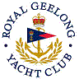 | Royal Geelong Yacht Club Inc.  Est 1859
Trophy Deed of Gift.

Trophy: | Geoff Wood Memorial Trophy (Sextant)
Presented by: | Life Member Geoff Wood
Date:
For: | Division 1 Event so Nominated
Remarks / Revisions
Click here for a List of Recipients
